THE 18TH IND. ARTILLERY
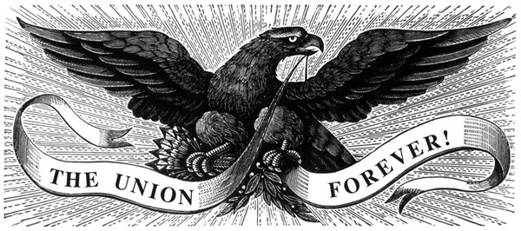
ON EVERY FIELD!

INDIANA BOYS

LILLY’S HOOSIER BATTERY!
In This Great Emergency Our Government Wants Men!
Men with stout hands and willing hearts, men who will fight manfully for our just and holy cause.
AROUSE
MEN OF INDIANA!
And respond nobly to this call as you have done to others. Listen not to those who would
Deter you from going; they will approach you in a thousand ways; heed them not; they have wily tongues but are TRAI-
TORS AT HEART.
The undersigned has been authorized
by His Excellency O. P. Morton, Governor of Indiana, to raise a
Battery, to be known as the 18th Battery Indiana Light Artillery; head- quarters, for the present at Greencastle, to be organized as follows: 1
Captain, 2 First Lieutenants, 2 Second Lieutenants, 1 First Sergeant,
1 Quartermaster Sergeant, 6 Sergeants, 12 Corporals, 2 Buglars, 2 Blacksmiths, 2 Wagon
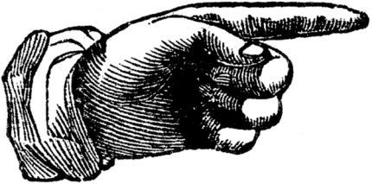

Makers, 2 Harness Makers, 1 Wagoner, 122 Privates Total, 156 men. The battery will consist of
SIX, TEN POUNDER
PARROT GUNS
AS IT IS DESIGNED to make this the crack battery of Indiana.

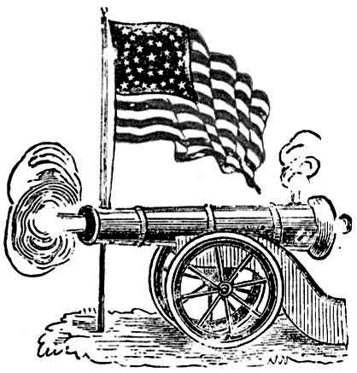
No man need apply for enrollment unless he is sound in every particular.
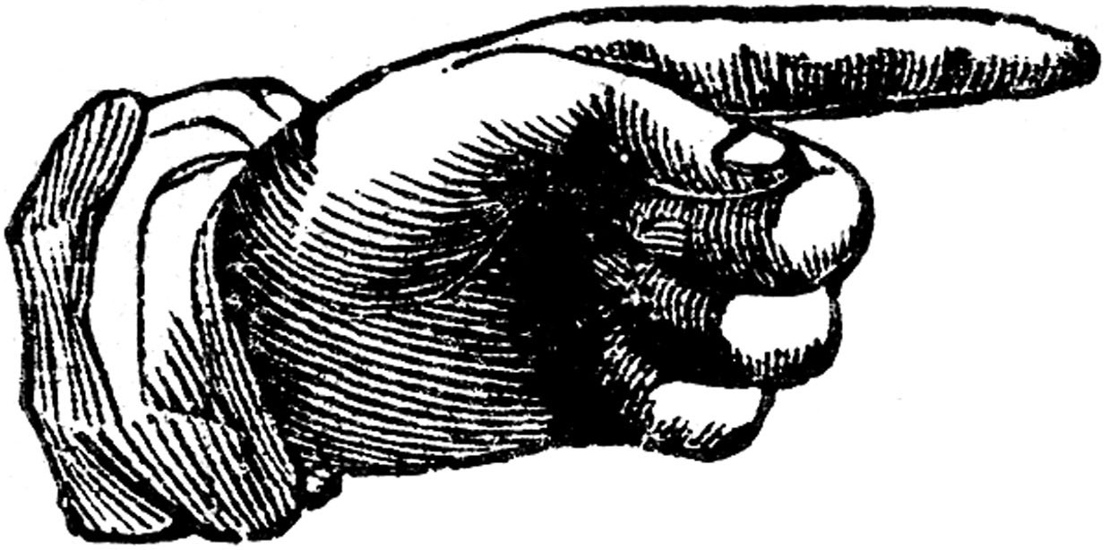 “A premium of $2,00 will be paid for each acceptable recruit. Every Vol-
unteer who enlists for three years or during the war, shall receive his first month’s
pay in advance, upon mustering his company into the service of the United States,
and shall in addition thereto rewceive $25,00 of the One Hundred Dollars Bounty,
which shall be paid when the company is raised to the minimum number. (Gen’l
orders No. 49) Each recruit receives $100,00 Bounty, and from $13,00 to $31,00 per month.

ELI LILLY,
July 9th, 1862 Headquarters at the Drug Store, S. E. Corner, Public Square, Greencaslte, Indiana.

J. SCOTT of Bainbridge, late of the 16th Indiana, is fully authorized by me to recruit for the above Battery. E. LILLY

