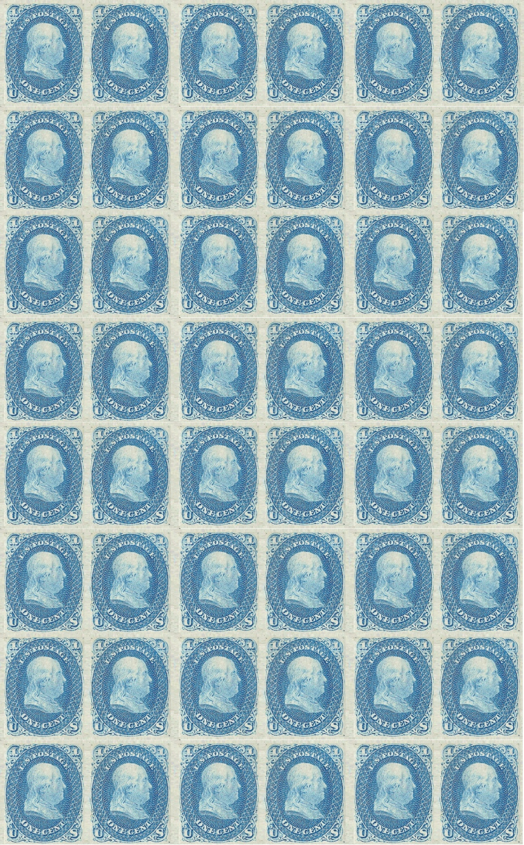
Instructions: Print as a full size word document. Coat back of stamp sheet with a non-toxic glue stick, and allow to dry. Perforations can be achieved with the use of a 1/16” hole punch. Permission is granted for anyone to use these stamps, but they are not to be sold, and please give credit to the 18th Indiana Light Artillery.

